NAME: _____________ | Stats and probability
Sampling – Gypsy Moth | DATE: Monday, April 10, 2017

CLASSWORK: Gypsy Moth Infestation

Pine forests are periodically infected with Gypsy Moths and the infestations often spread through direct tree to tree contact infecting large clumps of trees in a few locations. How can a forester choose a good sampling method to count diseased trees? Examine the diagram below; each dot on the diagram represents a diseased tree in the forest. The diagram has been split up into boxes to help perform sampling more easily.

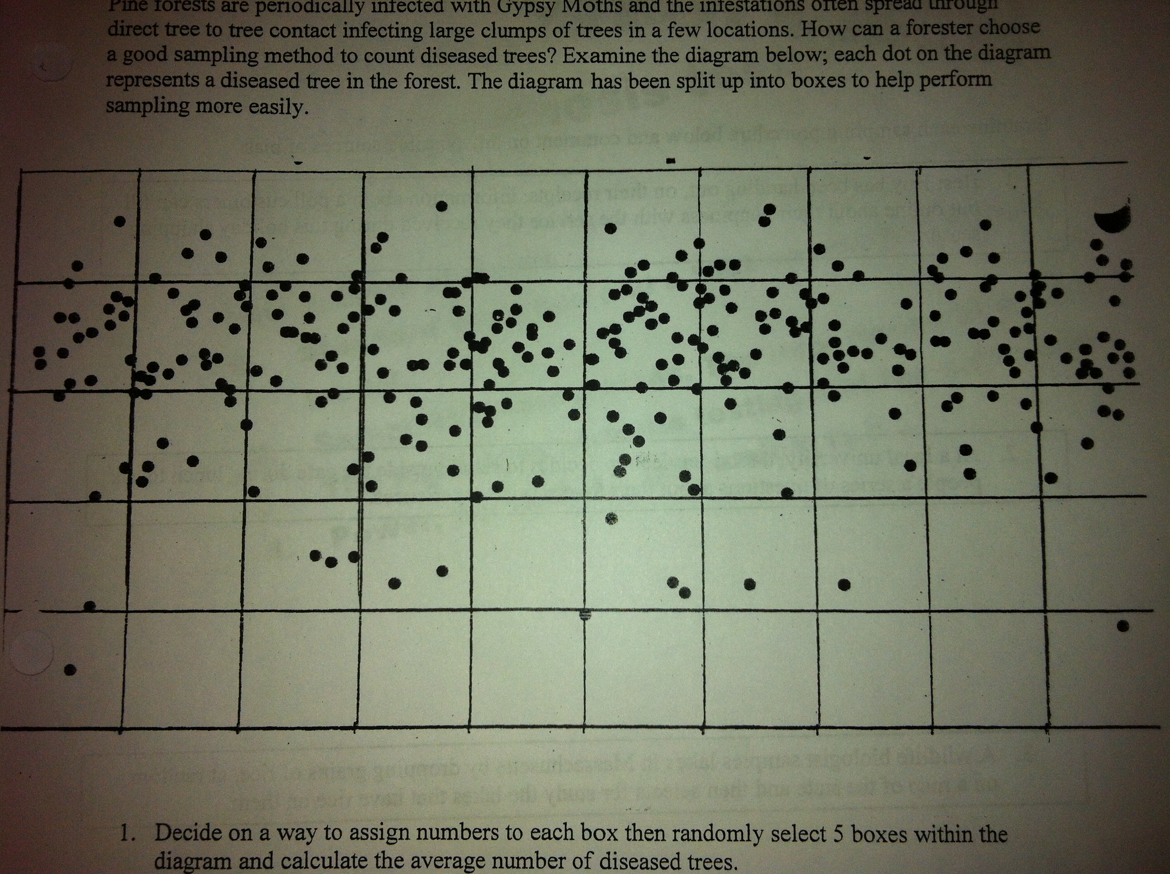

- Decide on a way to assign numbers to each box then randomly select 5 boxes within the diagram and calculate the average number of diseased trees.

- Conduct a stratified sample (should it be horizontal or vertical) and get a sample of 5 boxes and find that average.

- Conduct a cluster sample and get a sample of 5 boxes and find that average.

Which one do you think is the best?

Which was the easiest to do?
1. Categorize each technique as a simple random sample, stratified sample, systematic sample, cluster sample or convenience sample.
- To conduct a pre-election opinion poll on a proposed amendment to the state constitution, a random sample of 10 telephone prefixes (first three digits of the phone number was selected and all households from the phone prefixes selected were called.

- To conduct a study on depression among the elderly, a sample of 30 patients in one nursing home was used.

- To maintain quality control in a brewery, every 20th bottle of root beer coming off the production line was open and tested.

- Subscribers to the magazine Sound Alive were assigned numbers. Then a sample of 30 subscribers was selected by using a random-number table. The subscribers in the sample were invited to rate new headphones for a “What do Subscribers Think” column.

- To judge the appeal of a proposed television sitcom, a random sample of 10 people from each of three different age categories was selected and those chosen were asked to rate a pilot show.

- A television reporter interviewed travelers stranded at an airport during a snowstorm about the efficiency of air travel in Portland.

2. How would you conduct a sample if you wanted to find?
- The average speed of cars on the highway.

- What percent of seniors are planning on going to college next year ?

- How students at Deering feel about WINN?

- We want to see if high school students in rural Maine take illegal drugs at a higher rate that in Portland. We are going to conduct a survey to find out the average percent of all rural students that take illegal drugs. We researched that there are 155 small rural schools (of less than 100 students).

